

**CAPSTONE PROJECT REPORT**

**HVT**

**DIGITAL TRANSFORMATION**

|  |  |  |
| --- | --- | --- |
| **SWP490_G24** | | |
| **Project team** | Vu Bao Yen | SE05610 |
| Pham Trong Kim | SE05423 |
| Nguyen Tung Lam | SE05790 |
| Nguyen Thi Kim Loan | SE05636 |
| Supervisor | Mr. Tran Binh Duong | |
| **Project code** | HVT Digital Transformation | |

**TABLE OF CONTENTS**

**CHAPTER 5: SOFTWARE TEST DOCUMENTATION** 4

**1.** **INTRODUCTION** 4

**1.1.** **Purpose** 4

**1.2.** **Overview** 4

**2.** **TEST PLAN** 4

**2.1.** **Introduction** 4

**2.2.** **Requirements for Test** 7

**2.3.** **Test Strategy** 7

**2.4.** **Resource** 9

**2.5.** **Test Milestones** 9

**3.** **TEST REPORT** 10

**3.1.** **Unit Test** 10

**3.2.** **Integration Test** 12

**3.3.** **System Test** 13

**3.4.** **Bug Log** 14

**3.5.** **Evaluating solution of problem “Assignment of Red Stars” with Genetic Algorithm** 15

**TABLE OF FIGURES**

Figure 1: Agile Testing Process 5

Figure 2: Test Report of Unit Test Case 10

Figure 3: Test Report of Unit Test Report (1) 11

Figure 4: Test Report of Unit Test Report (2) 11

Figure 5: Test Report of Integration Test Case 12

Figure 6: Test Report of Integration Test Report 12

Figure 7: Test Report of System Test Case 13

Figure 8: Test Report of System Test Report 13

Figure 9: Bug log 14

Figure 10: Chart of evaluating the average convergence generation time of the algorithm 15

Figure 11: Chart of evaluating the variation of the number of conflicts per generation 15

# **CHAPTER 5: SOFTWARE TEST DOCUMENTATION**

## **INTRODUCTION**

### **Purpose**

This section is designed to prescribe the scope, stage, type of testing, some risks and issues. It also identifies the test criteria, test resource, and test environment. The format test case, test report, and result of all tests is illustrated at the end of this section.

### **Overview**

This document includes 2 sections below:

* Section 2: describe the plan of testing
* Section 3: describe the test report

## **TEST PLAN**

### **Introduction**

#### **Purpose**

This document describes the plan for testing the developed software system against the software requirements as defined in the Software Requirements Specification and Detailed Document. The purpose of these tests is to make sure that the software system developed during the HVT digital transformation project complies with the requirements. The planning of these tests will be done in the planning phase, they will be designed in the Design phase and finally must be executed in the testing phase of each sprint in the project.

#### **Test Approach**

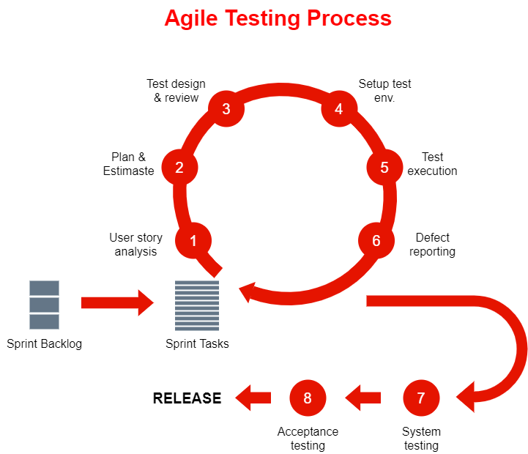

Figure : Agile Testing Process

#### **Definitions, Acronysm and Abbreviations**

|  |  |
| --- | --- |
| Abbreviations | Description |
| UT | Unit Testing |
| IT | Integration testing |
| ST | System testing |

#### **References**

|  |  |  |  |
| --- | --- | --- | --- |
| Title/File name | Author | Version | Effective Date |
| Software Requirement Specialization | SWP490_G24 | 3.0 | 18/08/2020 |

#### **Scope of Testing**

The scope of the test will be tested in web browsers of various devices. The testing will test the functional and non-functional of the system.

##### **Target of Test**

Functional items and Non-functional items will be verified and passed by SWP490_G24 development team, then be validated and approved by HVT gifted high school via test stages, including the requirements of the following modules:

|  |  |
| --- | --- |
| * Manage account * Manage teacher * Manage class * Manage timetable * Manage school year * Manage violation | * Manage violation entering time * Manage assign Red Star * Manage emulation * Manage school rank * Manage newsletter |

##### **Test Stage**

|  |  |  |
| --- | --- | --- |
| No | Test Stages | Description |
| 1 | Unit Test | Unit Test will be performed by SWP490_G24 development team. |
| 2 | Integration Test | Integration Test will be performed by SWP490_G24 team.  After the Unit Test is finished, testers will execute Integration Test.  This test stage focuses on specific areas of use cases when all requirements are completed, integration tests should be performed to ensure all components incorporate well. |
| 3 | System Test | System Test will be executed by the SWP490_G24 team.  Testers will perform complete, end-to-end system testing staged in the pre-production environment to validate that functions and system interfaces perform properly in the production environment. |
| 4 | Acceptance Test | **Acceptance Test will be conducted by HVT Gifted High School**  School’s responsibilities during Acceptance Test phase are:   * Facilitate completion on the application deployment * Support fixing bugs * Support Final User Acceptance Test |

##### **Test Assumption**

The following assumptions are made for test process:

* + Hoang Van Thu Gifted High School is to validate and approve for final software product, test procedures and results
  + Verification from SWP490_G24 project team for test execution, documenting and results
  + Requirements for the test are limited to functional and non-functional requirements specified in Section 2 of this document.

#### **Constraints**

The following constraints may apply when testing is performed on system:

* + Deadline for testing only can be met if development progress is on time
  + Test execution can be performed when system passes Unit Test Inspection
  + At least one round of testing must be performed for requirements
  + Complete testing needs support from Hoang Van Thu Gifted High School for reality environment set-up.
  + Working processing must be reported at the end of the sprint.

### **Requirements for Test**

#### **Test Item**

The developer will implement the unit test to ensure that all functions are working as expected. The tester will be undertaking the responsibility of testing and validating the operation of the part that developed. The functions developed require completing the design and execution of the function to ensure proper coverage.

#### **Acceptance Test Criteria**

|  |  |  |
| --- | --- | --- |
| No | Test Stages | Qualified ratios |
| 1 | Unit Test | To pass this stage, all unit test cases must be tested and passed 100%. All defects should be fixed and re-tested. |
| 2 | Integration Test | To pass this stage, all test cases must be tested and passed 100%. All defects should be fixed and re-tested. At least 5 test cases/function. |
| 3 | System Test | To pass this stage, all test cases must be tested and passed 100%. All defects should be fixed and re-tested.  Test on the environment that is Chrome Web browser of sony and laptop. |
| 4 | Acceptance Test | Acceptance Test will be conducted and approved on Acceptance Minute by Hoang Van Thu Gifted High School. |

### **Test Strategy**

#### **Test Type**

##### **Function Testing**

Unit testing searches for defects in each function, and verifies the function of HVT Digital Transformation application. Application and tests whether its functions are implemented properly as required or not.

|  |  |
| --- | --- |
| Test Objective | Ensure proper target-of-test functionality, including navigation, data entry, processing, and retrieval. |
| Technique | Execute each use case, use-case flow, or function, using  valid and invalid data, to verify the following:  - The expected results occur when valid data is used.  - The appropriate error or warning messages are  displayed when invalid data is used. |
| Completion criteria | All planned tests have been executed. |
| Special  considerations | None. |

##### **User Interface Testing**

Integration testing tests interfaces between components (Mobile screen), interactions with different parts of a system.

|  |  |
| --- | --- |
| Test Objective | Ensure the interface of the system in various devices will be simple to read and use. The test makes sure the interactions with the different parts of this system are successful. |
| Technique | Create or modify tests for each screen (application) to verify proper navigation and object states for each application window and objects. |
| Completion criteria | Each screen(application) successfully verified to remain consistent with the benchmark version or within acceptable standards. |
| Special  considerations | None. |

#### **Test Stages**

|  |  |  |  |  |
| --- | --- | --- | --- | --- |
| Types of Test | Stages of Test | | | |
| **Unit** | **Integration** | **System** | **Acceptance** |
| Function Test | ✓ | ✓ | ✓ | ✓ |
| User Interface test |  | ✓ | ✓ | ✓ |

#### **Tool**

|  |  |  |  |
| --- | --- | --- | --- |
| Purpose | Tool | Vendor/In-house | Version |
| Defect log | Excel | Microsoft |  |
| Documenting | MS Word, Excel | Microsoft | 2010 |
| Function Testing | Manual | Manual |  |

### **Resource**

#### **Human Resource**

|  |  |  |
| --- | --- | --- |
| Worker/Doer | Role | Specific Responsibilities/Comments |
| Nguyễn Tùng Lâm | Test Leader | Manage test resources and assign test tasks  Create Test Plan, Test Cases (IT, ST), Test Scripts (IT, ST)  Review Test Data  Create Test Reports |
| Phạm Trọng Kim | Tester | Review Test Cases (IT, ST)  Create Test Data and Execute Test (IT, ST)  Report Test Results |
| Vũ Bảo Yến | Quality Assurance | Final Inspection Test Cases, Test Plan, Test Reports |
| Nguyễn Tùng Lâm | Developer | Create UT Cases, UT Reports |
| Phạm Trọng Kim | Developer | Create UT Cases, UT Reports |

#### **Environment**

|  |  |
| --- | --- |
| Software | Version |
| Chrome | Version 84.0.4147.125 |

|  |  |
| --- | --- |
| Hardware | Version |
| Sony Smartphone | Android 6.0.1 |
| Laptop | Window 10 |

### **Test Milestones**

|  |  |  |  |
| --- | --- | --- | --- |
| Milestone Task | Effort (pd) | Start Date | End Date |
| * **Sprint 2** | | | |
| Create Test Plan | 1 | 18/06/2020 | 18/06/2020 |
| Review & Update Test Plan | 1 | 18/06/2020 | 18/06/2020 |
| * **Sprint 3** | | | |
| Create and Execute UT for module 1,2,3,4 | 1 | 09/07/2020 | 09/07/2020 |
| Review & Update  UT for module 1,2,3,4 | 1 | 10/07/2020 | 10/07/2020 |
| Create and Execute IT for module 1,2,3,4 | 2 | 11/07/2020 | 12/07/2020 |
| Review & Update  IT for module 1,2,3,4 | 1 | 13/07/2020 | 13/07/2020 |
| * **Sprint 4** | | | |
| Create and Execute UT for module 5,6,7,8,9,10 | 2 | 02/08/2020 | 03/08/2020 |
| Review & Update  UT for module 5,6,7,8,9,10 | 1 | 03/08/2020 | 03/08/2020 |
| Create and Execute IT for module 5,6,7,8,9,10 | 3 | 04/08/2020 | 06/08/2020 |
| Review & Update  IT module 5,6,7,8,9,10 | 1 | 07/08/2020 | 07/08/2020 |
| Create and Execute UT for module 11 | 1 | 09/08/2020 | 09/08/2020 |
| Review & Update  UT for module 11 | 1 | 09/08/2020 | 09/08/2020 |
| Create and Execute IT for module 11 | 1 | 09/08/2020 | 09/08/2020 |
| Review & Update  IT module 11 | 1 | 09/08/2020 | 09/08/2020 |
| Create and Execute ST | 2 | 10/08/2020 | 11/08/2020 |
| Review & Update ST | 1 | 11/08/2020 | 11/08/2020 |

## **TEST REPORT**

### **Unit Test**

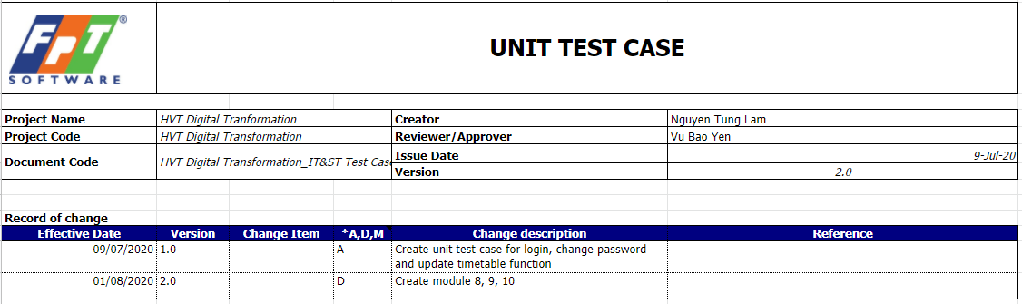

Figure : Test Report of Unit Test Case

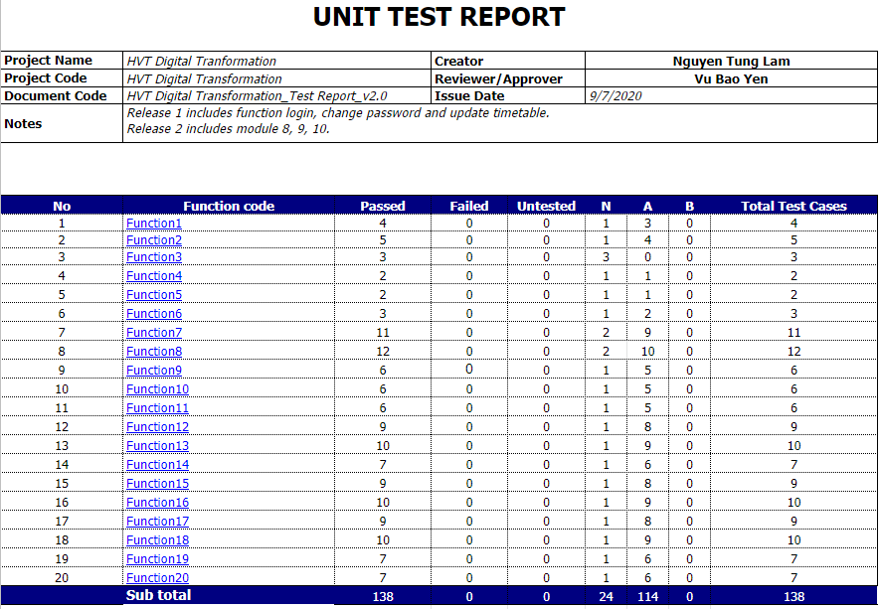

Figure : Test Report of Unit Test Report (1)

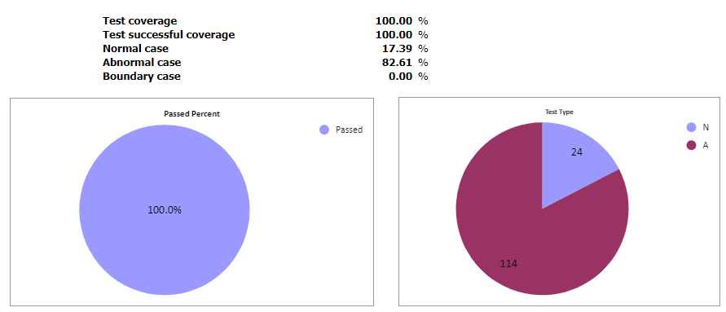

Figure : Test Report of Unit Test Report (2)

The details of this document are referenced at the following link: <https://docs.google.com/spreadsheets/d/1_3PeuGilXDa5oVAFwfP9FYRzPc9mbOaBIi4oX6aIpaY/edit?usp=sharing>

### **Integration Test**

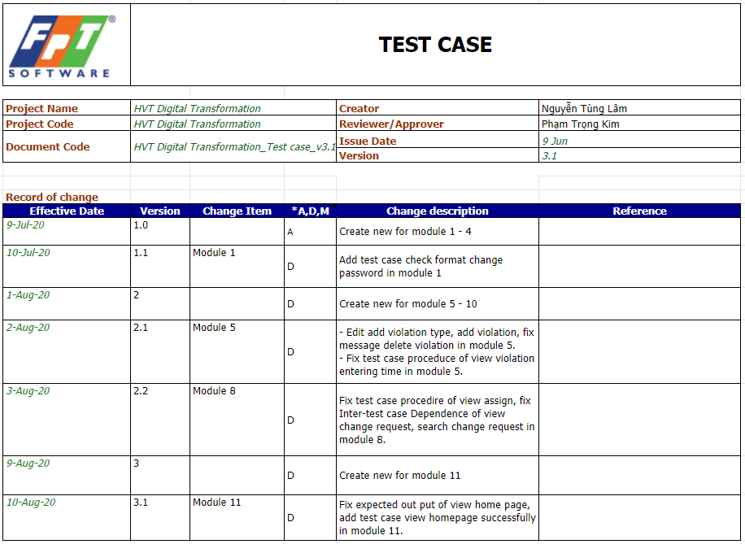

Figure : Test Report of Integration Test Case

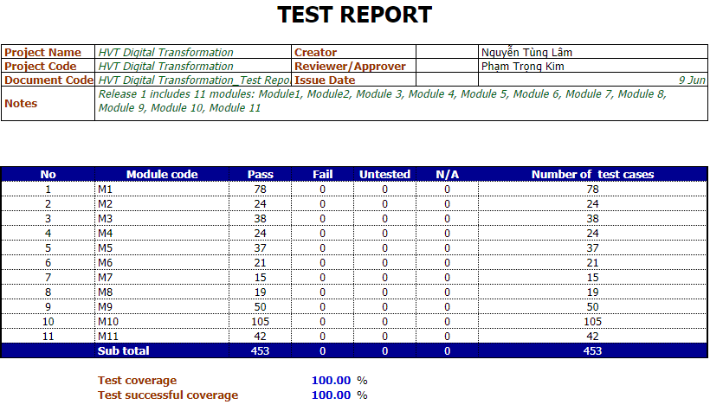

Figure : Test Report of Integration Test Report

The details of this document are referenced at the following link: <https://docs.google.com/spreadsheets/d/1KtV3P1D8TQ4eEZtfCZHY6fg6VUdqnAi86VT88LddI9M/edit?usp=sharing>

### **System Test**

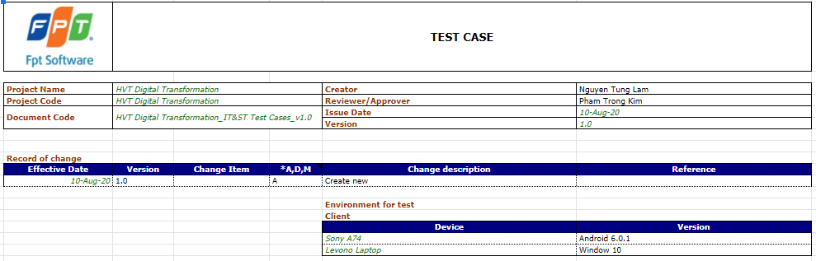

Figure : Test Report of System Test Case

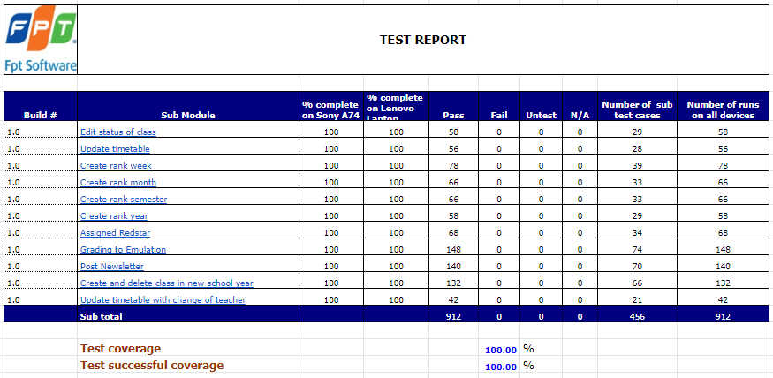

Figure : Test Report of System Test Report

The details of this document are referenced at the following link: <https://docs.google.com/spreadsheets/d/1nyvpYDUGt3PVKG6wiOxnzS6OXVqVTK6g8rCJdzSotkk/edit?usp=sharing>

### **Bug Log**

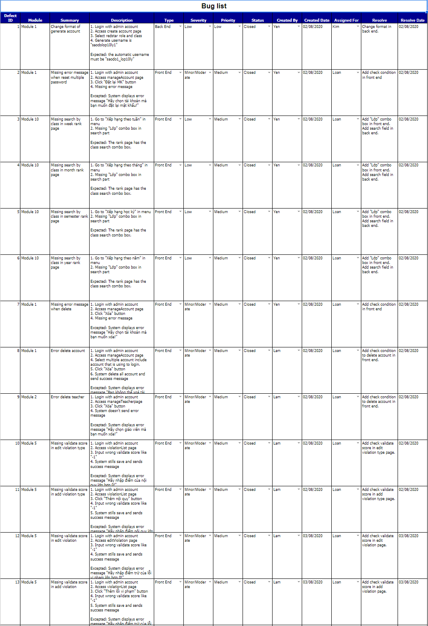

Figure : Bug log

The details of this document are referenced at the following link: <https://docs.google.com/spreadsheets/d/1xXAr4ilu_piwE8GyEI5mjs4WyMIEYQdnH5MrjD3Ba_Y/edit?usp=sharing>

### **Evaluating solution of problem “Assignment of Red Stars” with Genetic Algorithm**

#### **Evaluating the average convergence generation time of the algorithm**

Figure 10: Chart of evaluating the average convergence generation time of the algorithm

#### **Evaluating the variation of the number of conflicts per generation**

Figure 11: Chart of evaluating the variation of the number of conflicts per generation